Title: Design and Implementation of Digital Circuits in Microwind

1. 4-Bit Full Adder

A 4-bit Full Adder is designed to generate a 4-bit Sum and is designed by combining four 2-bit Full Adders and the Four bits output along with the Carry Bit.

Circuit Diagrams: - Truth Tables: -

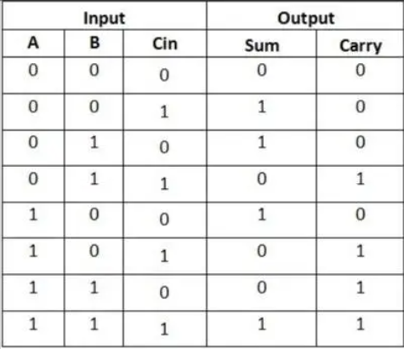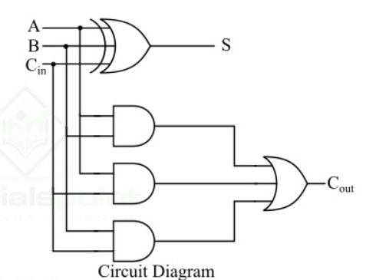

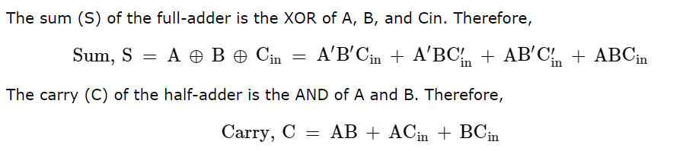Logic Equations: -

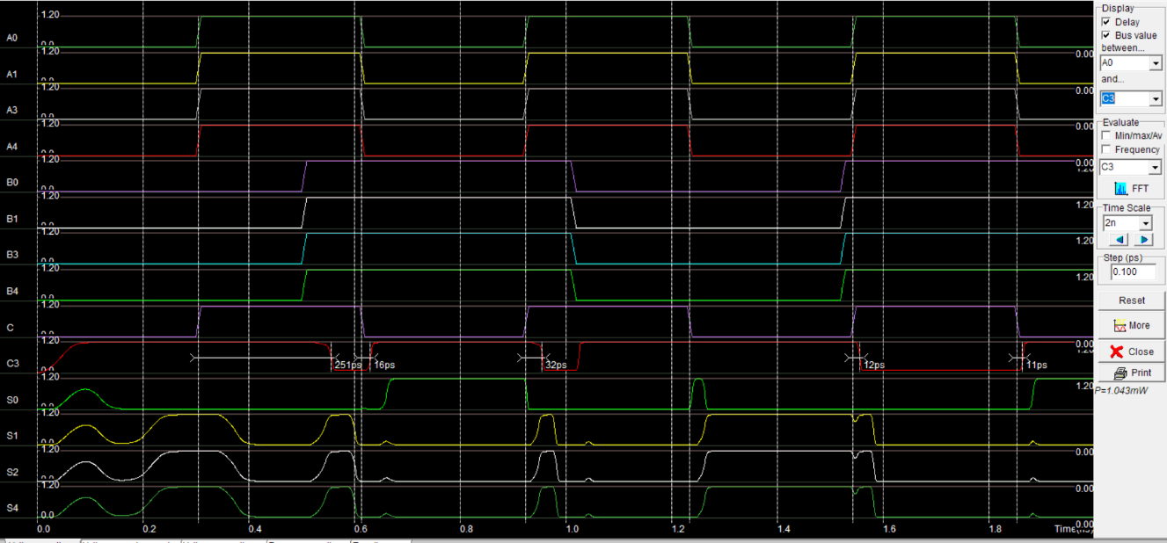Screenshots Of Layouts: -

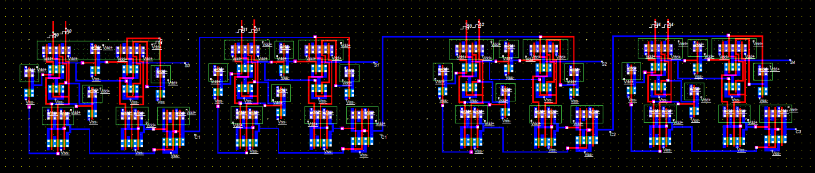

1. 8×1 Multiplexer

The 8×1 Multiplexer is made using 4×1 Multiplexers and 2×1 Multiplexer. We know that 4×1 Multiplexer has 4 data inputs, 2 selection lines and one output. Whereas, 8×1 Multiplexer has 8 data inputs, 3 selection lines and one output.

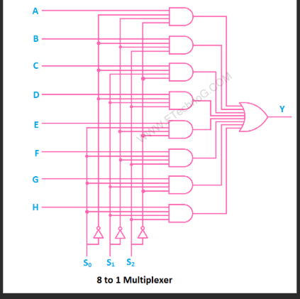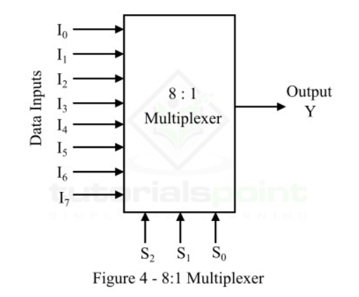Circuit Diagrams: - Block Diagram: -

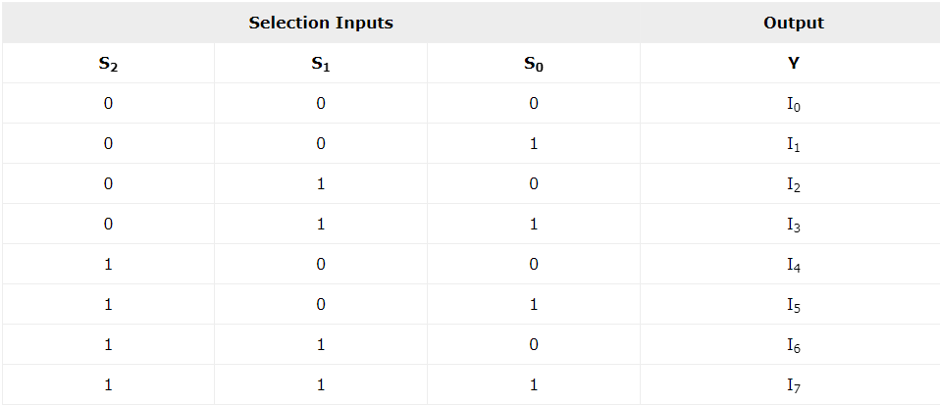Truth Tables: -

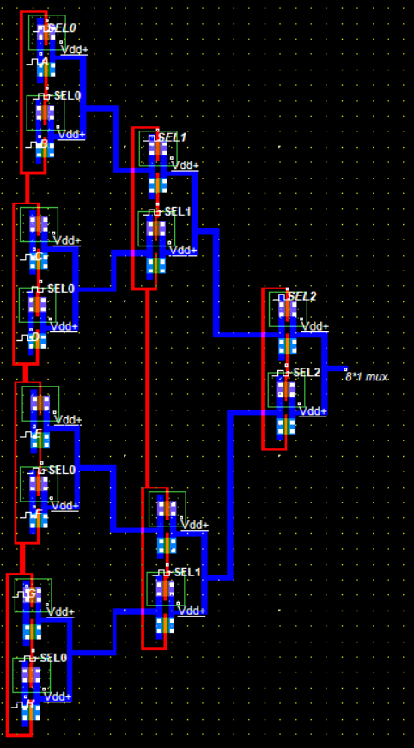

Logic Equations: -

*Y*= *S*2​​*S*1​​*S*0​​*I*0​+*S*2​​*S*1​​*S*0​*I*1​+*S*2​​*S*1​*S*0​​*I*2​+*S*2​​*S*1​*S*0​*I*3​+*S*2​*S*1​​*S*0​​*I*4​+*S*2​*S*1​​*S*0​*I*5​+*S*2​*S*1​*S*0​​*I*6​+*S*2​*S*1​*S*0​*I*7​

Screenshots Of Layouts: -

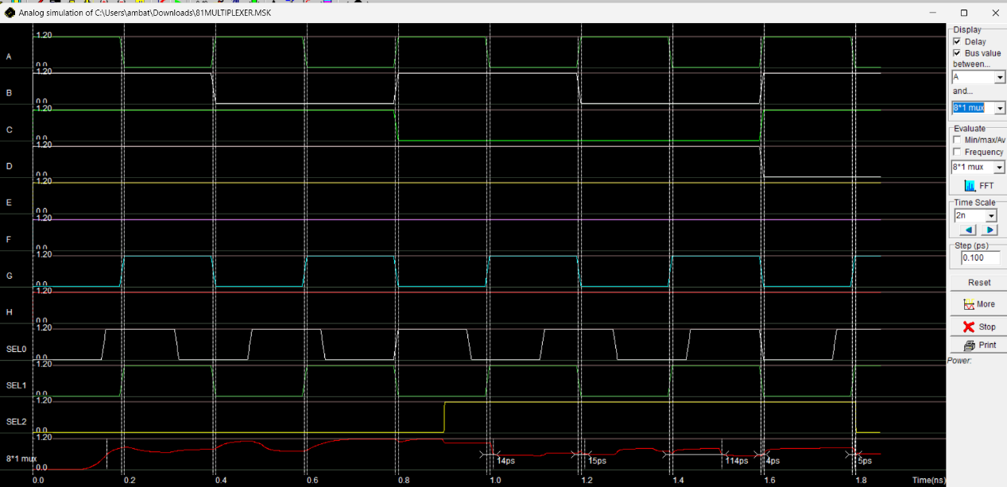

1. 1-bit Magnitude Comparator

A 1-bit magnitude comparator circuit diagram compares two 1-bit binary inputs (A and B) and produces outputs indicating whether A is greater than, equal to, or less than B. The circuit typically uses logic gates like XOR, AND, and NOT gates to implement these comparisons. The output signals would represent the comparison outcomes: A > B, A = B, or A < B.

Circuit Diagrams: - Truth Tables: -

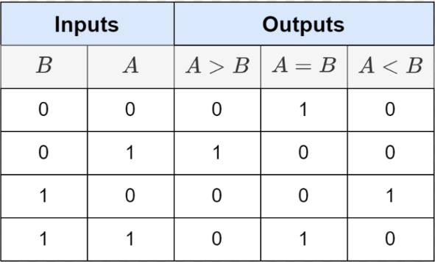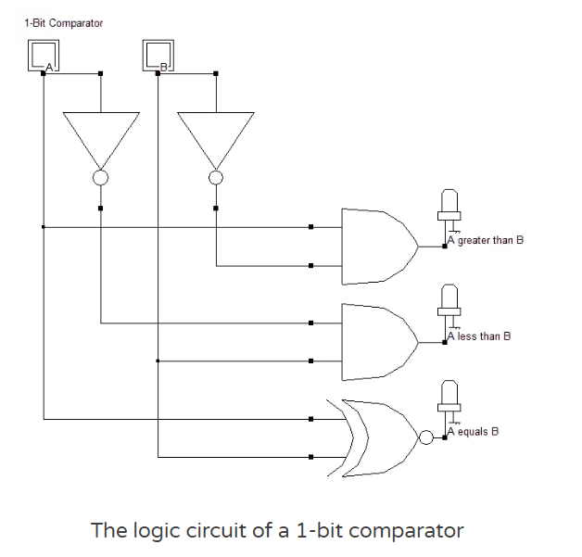

Logic Equations: -



Screenshots Of Layouts: -

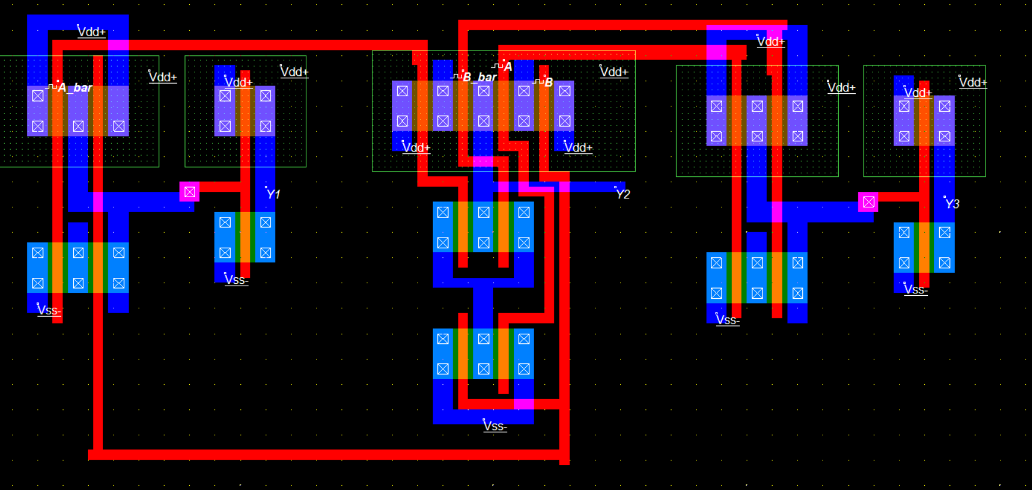

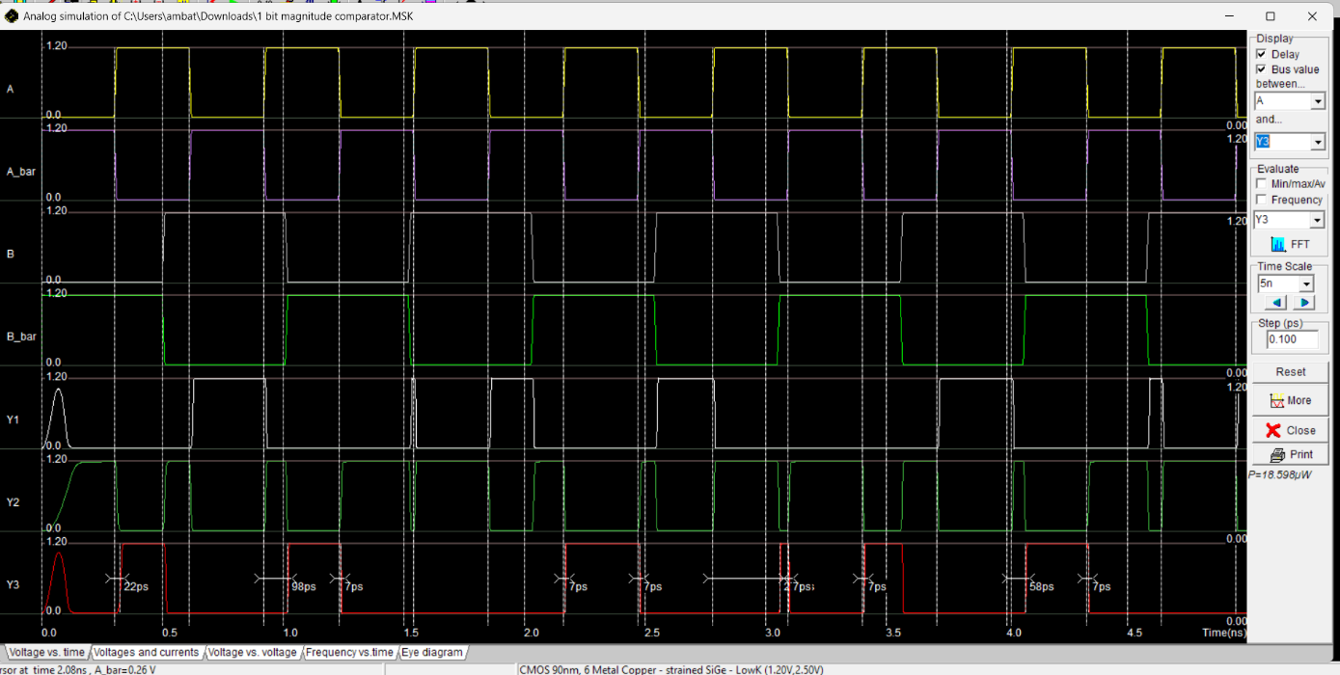

1. 4-bit Serial-In Serial-Out (SISO) Register

The term “SISO” stands for “Serial-In Serial-Out”. The SISO shift register circuit accepts serial data on its input pin and shifts it out serially on its output pin. The number of bits that can be shifted out before the next bit arrives depends on the speed of the clock signal that controls the operation of the shift register. This type of shift register can be used as a buffer between two asynchronous devices that communicate with each other using signals with different frequencies or phases.

Circuit Diagrams: -

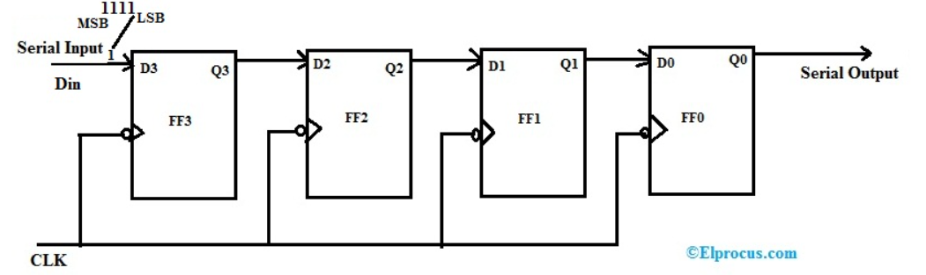

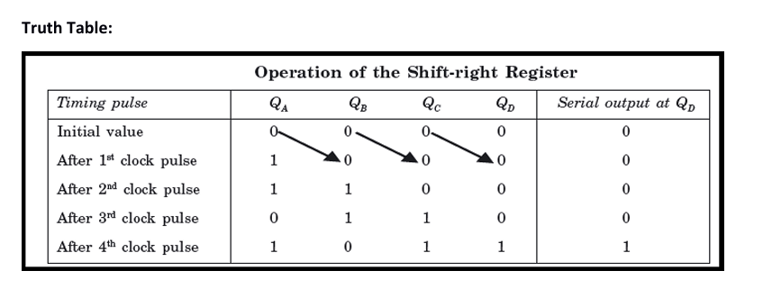

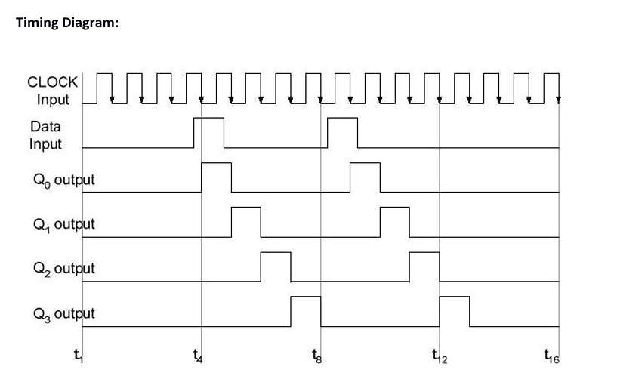

Screenshots Of Layouts: -